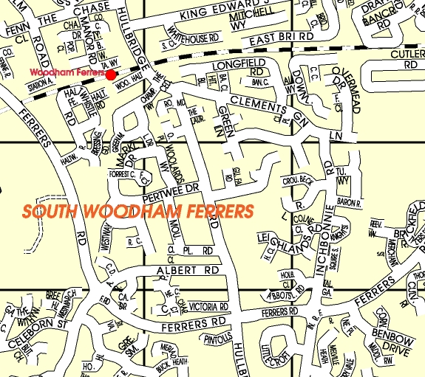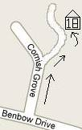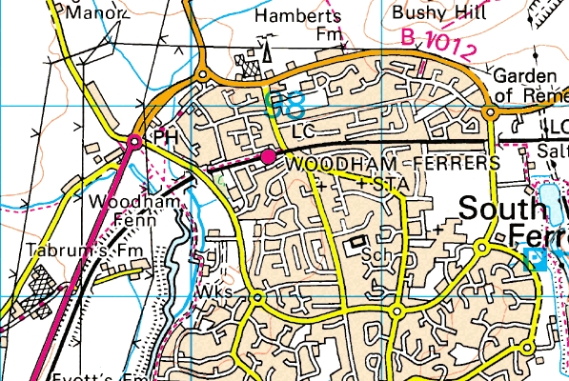
18 Cornish Grove.
Map to: Food Allergy Testing Ltd.
18 Cornish Grove, South Woodham Ferrers, Chelmsford, Essex. CM3 5XX. Tel: 01245 426032. (Please park on drive).

Asda

A

A
18 Cornish Grove.
A132
Benbow drive
Zoom view 1
Zoom view 2
Shaw Farm pub

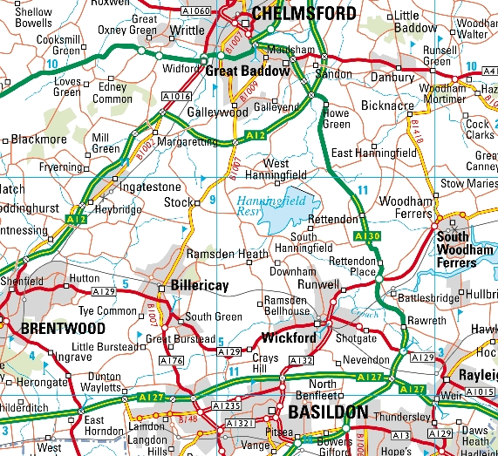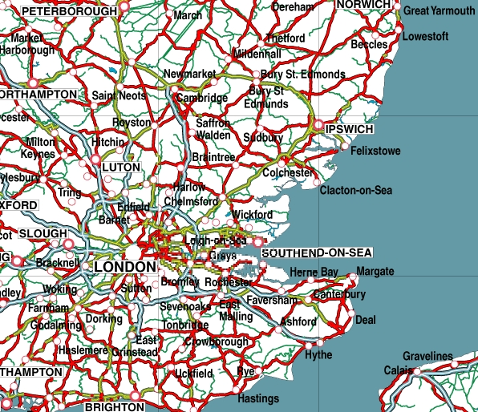
A132
M25
A12
A127
A130
We are here
A12
M11
A127
We are here
London
A13
Dartford tunnel
M257
Zoom view 3
Zoom view 4

